App Name: AI Cost Auditor

The Core Problem
Most organisations:
- Use one shared API key for providers like OpenAI and Anthropic
- Cannot attribute spend to:
  - Teams
  - Products
  - Individual developers
  - Automated agents
- Have no visibility into waste, such as:
  - Repeated massive prompts
  - Overuse of reasoning / “Chain-of-Thought”
  - Prompt retries caused by bad app logic
  - Inefficient context windows
- Discover overspend after the invoice arrives
This is the FinOps gap for LLM usage.

🧩 The Solution (Expanded Vision)
AI Cost Granular Auditor is a secure LLM proxy + financial intelligence layer that sits between applications and LLM providers.
It transforms raw token usage into:
- Cost attribution
- Behavioural insights
- Budget enforcement
- Waste detection
- Executive-level reporting
Positioning:
“The AWS Cost Explorer + Guardrails + CloudTrail for LLMs.”

🏗️ High-Level Architecture
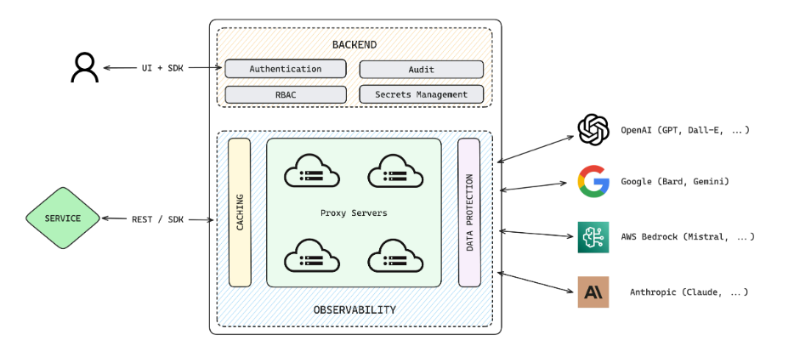
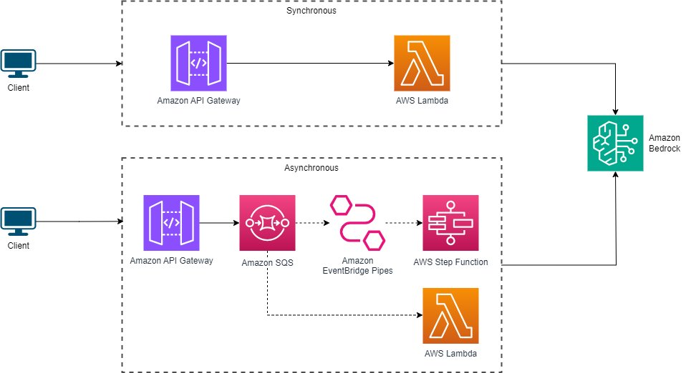
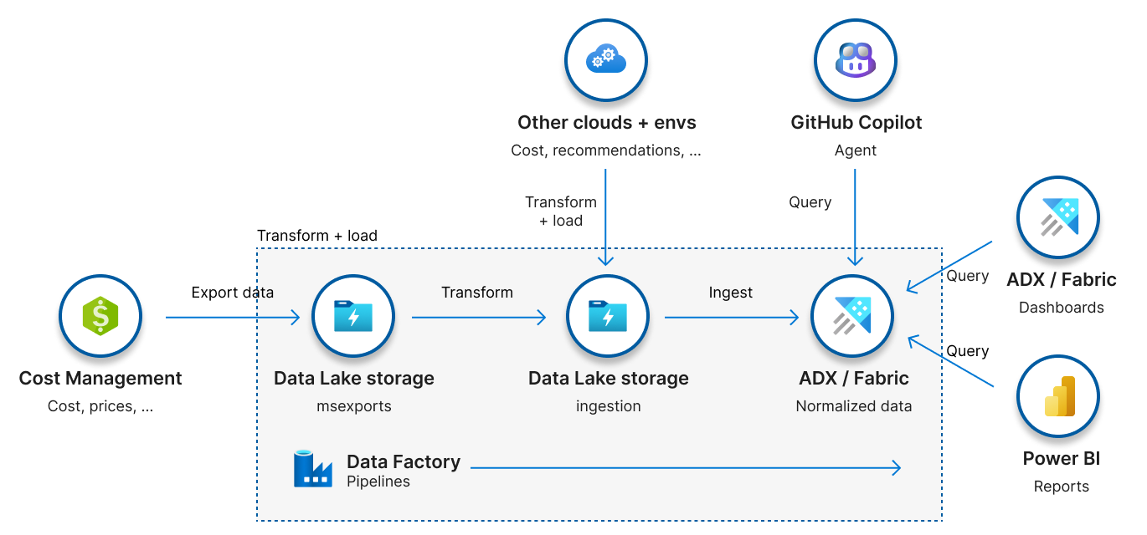
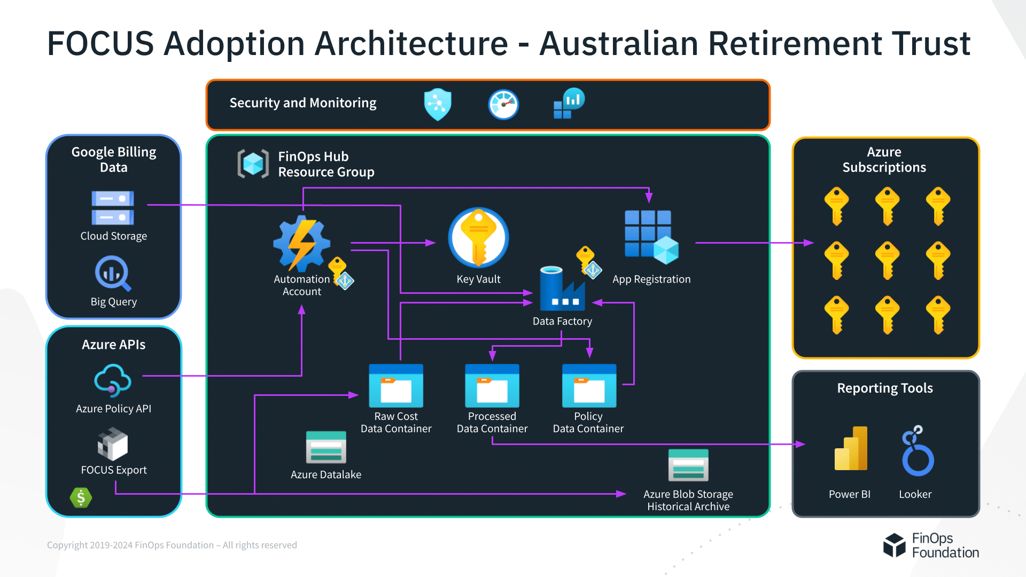
Flow:
App / Agent / Developer
↓
AI Cost Granular Auditor (Proxy)
↓
LLM Provider (OpenAI / Anthropic / etc.)

🔐 Virtual Keys (Enhanced)
Instead of one corporate key:
Virtual Key Metadata
Each request is tagged with:
- User
- Team
- Project
- Cost centre
- Environment (dev / staging / prod)
- Agent name (for autonomous AI)
Example
{
"virtual_key": "proj-hr-chatbot-dev",
"team": "HR",
"user": "alice@company.com",
"budget_cap": "$500/month",
"max_reasoning_tokens": 2000
}

📊 Dashboard (Beyond the Basics)
1. Cost Intelligence
- Cost per:
  - Prompt
  - User
  - Team
  - Project
  - Agent
- Daily / weekly / monthly burn rate
- Forecasted end-of-month spend
2. Waste Detection Engine (Key Differentiator)
Automatically flags:
- 🔁 Repeated prompts (hash similarity detection)
- 🧠 Over-reasoning (expensive thinking for simple tasks)
- 📦 Bloated context windows
- ❌ Prompt retries > X threshold
- 🤖 Runaway agents (infinite loops)
Metric Example:
“HR Bot re-sent a 12k token system prompt 47 times in 1 hour → £186 wasted.”

🚨 Guardrails & Controls (Major Upgrade)
Hard Controls
- Per-user / per-project:
  - Monthly budget caps
  - Max tokens per request
  - Max reasoning depth
- Kill-switch for runaway spend
- Time-based restrictions (e.g. no prod calls at night)
Soft Controls
- Warnings before expensive prompts
- Slack / Teams alerts:
  - “You’ve used 80% of your budget”
- Auto-downgrade model (GPT-4 → GPT-4o-mini)

🤖 Prompt Intelligence Layer (Advanced)
This is where the app becomes AI-native, not just accounting.
Prompt Classification
- Simple Q&A
- Reasoning-heavy
- Retrieval-augmented
- Creative generation
- Agent orchestration
Smart Optimisation Suggestions
- “This task does not require chain-of-thought”
- “Context window could be reduced by 62%”
- “Cache this system prompt”
- “Switch to cheaper model with no quality loss”

📜 Audit & Compliance (Enterprise Hook)
- Immutable usage logs
- Full prompt + response lineage (optional redaction)
- SOC 2 / ISO-aligned reporting
- Exportable for:
  - Finance
  - Internal audit
  - Regulatory review
Perfect for:
- Banks
- Insurance
- Government
- NHS-style organisations

🔌 Integrations (Make It Sticky)
Engineering
- SDKs: Python, JS, Java
- Drop-in OpenAI-compatible endpoint
- CI/CD spend checks (“PR increases prompt cost by 40%”)
Business
- Slack / Teams alerts
- Jira ticket creation for runaway costs
- Snowflake / BigQuery export
- AWS Cost Explorer-style CSVs

💼 Pricing Model (Optimised for Adoption)
SaaS Pricing
- Free Tier – up to $50 tracked usage
- Pro – % of spend tracked (e.g. 3–5%)
- Enterprise – flat fee + SLA + on-prem proxy
You win when they save money, which reduces sales friction.

🧠 Competitive Moat (Why This Wins)
Feature | Generic API Logs | Your App
Cost attribution | ❌ | ✅
Prompt-level waste detection | ❌ | ✅
Budget enforcement | ❌ | ✅
Agent runaway detection | ❌ | ✅
Prompt optimisation | ❌ | ✅
FinOps-ready reporting | ❌ | ✅

🧲 Killer One-Liner (Refined)
“AI Cost Granular Auditor is the AWS Cost Explorer for LLMs — with guardrails that stop waste before it happens.”
or
“Cut your AI API bill by 30% by finding the token hoarders, runaway agents, and bloated prompts.”

Further Enhancements
- Carbon footprint per prompt 🌱
- AI-generated monthly finance reports
- Internal chargeback automation
- Marketplace for “approved prompts”
- Benchmarking against similar companies

Full system architecture
1) High-level layout
Two planes (this is what makes it enterprise/FinOps-friendly):
Control Plane (Governance & Reporting)
- Admin + RBAC
- Virtual Key provisioning
- Policy config (caps, limits, model allowlists)
- Dashboards & reporting APIs
Data Plane (LLM Proxy / Enforcement)
- Low-latency proxy gateway
- Policy enforcement per request
- Usage extraction from upstream responses
- Audit logging / analytics events
Apps/Agents/SDKs
|
| X-Virtual-Key: vk_xxx
v
[LLM Proxy Gateway] -----> Upstream providers (OpenAI / Anthropic / etc.)
|
| writes UsageEvent + policy outcomes
v
[Postgres] -----> [Metrics API] -----> [React Dashboard]

2) Components
A) LLM Proxy Gateway (FastAPI)
Responsibilities
- Validates X-Virtual-Key
- Enforces policies before forwarding:
  - Monthly spend caps
  - Max token limits (best-effort pre-check)
  - Optional reasoning caps (best-effort)
- Forwards request upstream (OpenAI / Anthropic)
- Extracts token usage from response
- Computes cost using configurable per-1M token pricing defaults
- Logs a UsageEvent row for each request (even failures/blocks)
Endpoints in this starter
- POST /proxy/openai/v1/chat/completions
- POST /proxy/anthropic/v1/messages
B) Policy + Attribution Store (Postgres)
Core entities
- Organization, Team, Project
- VirtualKey (the attribution + policy container)
- UsageEvent (immutable audit log: costs, tokens, hash for repeats, block reasons)
C) Dashboard UI (React)
What it shows
- Spend today
- Spend month-to-date (MTD)
- Top users/projects (30d)
- Estimated “wasted repeats” (7d heuristic based on repeated prompt hashes)
- Admin screens: create virtual keys + list keys + view recent usage events
D) Observability
- Prometheus metrics: GET /metrics
- Health check: GET /healthz

3) Waste & “token hoarder” detection (architecture)
This starter includes a simple but effective baseline:
Repeated prompt detection (now)
- Hashes “dominant prompt fields” (messages/prompt + model)
- Stores only:
  - prompt_hash
  - prompt_chars
  - (optional) tiny prompt_preview snippet (safe-ish, configurable later)
- Dashboard calculates a “wasted repeats” estimate based on repeated hashes
Recommended next (upgrade path)
- Add semantic similarity (MinHash / embeddings) to catch “near duplicates”
- Add context-window bloat detector:
  - prompt size vs completion size
  - history window growth
- Add retry-loop detector:
  - same prompt hash repeatedly within short time window
- Add “agent runaway” detector:
  - high request rate + no successful outcomes

4) Security & enterprise hardening (architecture)
This repo is “production starter” — here’s the real-world security model:
Key principles
- Virtual Keys are NOT upstream provider keys (they’re internal identifiers).
- Upstream keys live only in secrets/env on the proxy.
- Store minimal prompt data (hash + tiny preview), or none at all.
Recommended enhancements
- SSO (OIDC/SAML) + SCIM user provisioning
- Field-level redaction policies
- Tenant isolation for multi-org SaaS mode
- Encrypt sensitive columns (if you ever store snippets)
- IP allowlists + mTLS inside corporate networks
- Separate write path (event queue) from request path for very high throughput

Generated production codebase (FastAPI + React)
What’s included
- FastAPI backend
  - JWT auth (/api/auth/token, /api/auth/me)
  - Admin endpoints to create and list virtual keys
  - Metrics endpoint (/api/metrics/overview)
  - Proxy endpoints for OpenAI/Anthropic
  - Alembic migrations + seed script
- React frontend (Vite + TS)
  - Login page
  - Dashboard charts (Recharts)
  - Admin page (create VKs, list VKs, view recent usage)
- Docker Compose
  - Postgres
  - Redis (wired, future-ready)
  - Backend
  - Frontend

Run it locally
- Unzip
- Start:
docker compose up --build
Then open:
- UI: http://localhost:5173
- API: http://localhost:8000
- Metrics: http://localhost:8000/metrics
Demo credentials (seeded)
- Email: admin@local
- Password: admin123

How to send traffic through the proxy
OpenAI-style chat completion
POST http://localhost:8000/proxy/openai/v1/chat/completions
Headers:
- X-Virtual-Key: <your_vk>
Body:
{
"model": "gpt-4o-mini",
"messages": [{"role":"user","content":"Hello!"}]
}
Anthropic messages
POST http://localhost:8000/proxy/anthropic/v1/messages
(Anthropic format body)

